Liz Beltran, TL 6

Menu and User Interface

**Brief Introduction**

My feature for the *Breaking Red* game is the Menu and the User Interface.

When the game is initially loaded, my job is to make sure the player has the option to start a new game and that a returning player can resume the game where they left off.

The player also has the option to pull up the menu when pausing the game. From here, they have the option to resume the game, save the game, restart a new game, and to exit.

Key Responsibilities:

1. Main Menu Design
   1. Provide clear instructions to start the new game or continue an existing one.
   2. Implement an intuitive and visually appealing layout.
2. User Interface Elements
   1. Display essential information such as player statistics.
   2. Display the inventory of the character.
   3. Subtitles for the dialogue with the Non-Player Characters.
3. Save and Load Functionality
   1. Enable players to save their progress and reload it seamlessly.

**Use Case Diagram with Scenarios**

**Use Case Diagram #1**

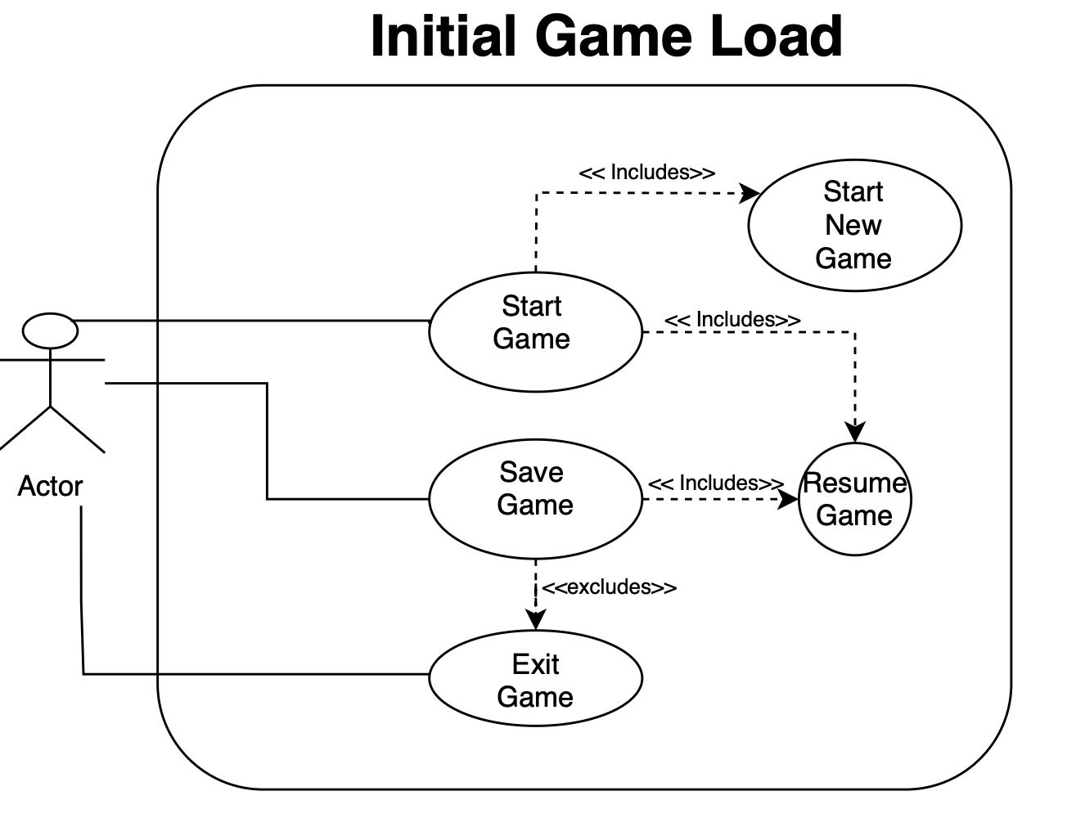

**Scenario (Use case Diagram #1)**

**Name: Game Initial Load**

**Summary:** The game loads and the player will see the menu screen.

**Actors:** Player

**Preconditions:**

**Basic Sequence:**

**Step 1:**

**Step 2:**

**Step 3:**

**Exceptions:**

**Step #:**

**Step #:**

**Post conditions:**

**Priority: 2**

**ID:**

The priorities are 1 = Must have, 2 = Essential, 3= Nice to have

**Use Case Diagram #2**

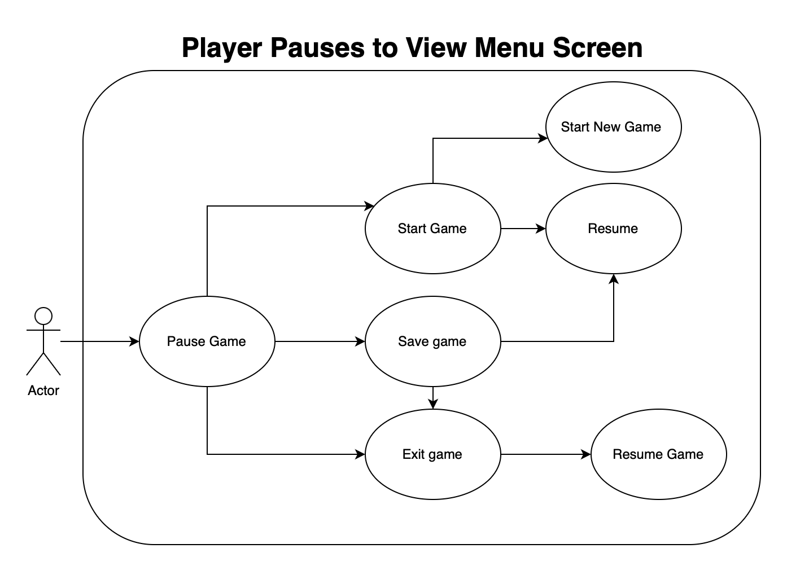

**Scenario (Use case Diagram #2)**

**Name:** Player pulls up menu screen while playing.

**Summary:** The player pulls up the menu while playing the game.

**Actors:** Player

**Preconditions:** Player has already started the game.

**Basic Sequence:**

**Step 1:**

**Step 2:**

**Step 3:**

**Exceptions:**

**Step #:**

**Step #:**

**Post conditions:**

**Priority: 2**

**ID:**

The priorities are 1 = Must have, 2 = Essential, 3= Nice to have

**Use Case Diagram # 3**

**Picture here**

**Scenario (Use case Diagram #3)**

**Name:**

**Summary:**

**Actors:** Player

**Preconditions:** Player has already started the game.

**Basic Sequence:**

**Step 1:**

**Step 2:**

**Step 3:**

**Exceptions:**

**Step #:**

**Step #:**

**Post conditions:**

**Priority: 2**

**ID:**

The priorities are 1 = Must have, 2 = Essential, 3= Nice to have

**Data Flow diagram from level 0 to process description for feature.**

In the data flow diagrams below, I will be covering the Menu and User Interface Feature entirely.

Data Flow Diagrams

* Diagram 0
* Diagram 1

**Process Description**

**Acceptance Tasks**

**Timeline**

Work Items:

|  |  |  |
| --- | --- | --- |
| Task | Duration (Hours) | Predecessor Task(s) |
|  |  |  |
|  |  |  |
|  |  |  |
|  |  |  |

**Pert Diagram**

picture here

**Gantt Timeline**

Key:

Picture here

References to code the Menu and some of the UI :

<https://www.red-gate.com/simple-talk/development/dotnet-development/how-to-create-a-settings-menu-in-unity/>

<https://gamedevacademy.org/unity-start-menu-tutorial/>